 | PES University, Bengaluru  (Established under Karnataka Act No. 16 of 2013) | UE18CS303
NOVEMBER 2020: IN SEMESTER ASSESSMENT B Tech CSE 5th SEMESTER
TEST – 2

UE18CS303 – MACHINE INTELLIGENCE

Time: 80 Minutes | Answer All Questions | Max Marks: 40

1. | a) | (i) Explain how to use the elbow method to find the most optimal value of k in k-means clustering. Explain what is an elbow point. (2+1)  (ii) Is convergence always guaranteed in k-means? (1)  (iii) In the given figure below what is the most optimal value of k? (1)  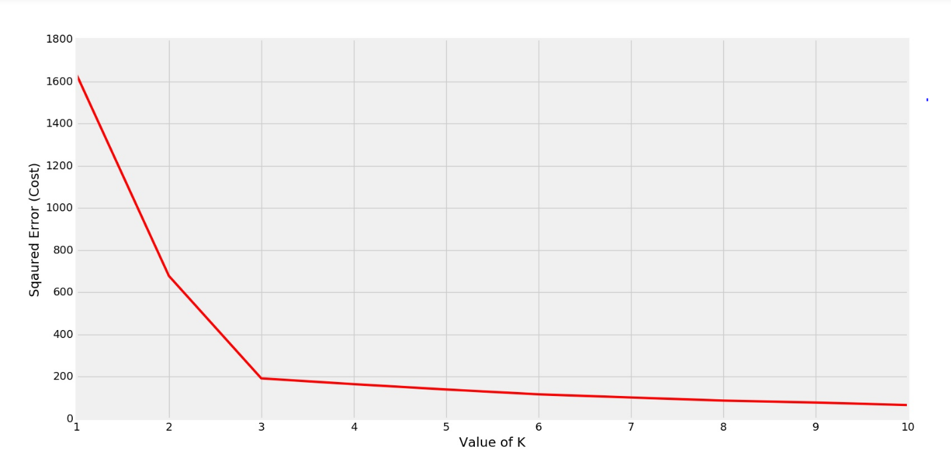  ANSWER:  - There is a popular method known as the elbow method which is used to determine the optimal value of K to perform the K-Means Clustering Algorithm. The basic idea behind this method is that it plots the various values of cost with changing k. As the value of K increases, there will be fewer elements in the cluster. So average distortion will decrease. The lesser number of elements means closer to the centroid. So, the point where this distortion declines the most is the elbow point.  - Yes  - K = 3 | 5
1. | b) | Determine the frequent itemsets for the following transactions with a minimum support value of 50%. Build the associate rule graph and determine any two associate rules having a confidence value greater than 75%.  ANSWER:  - 3 item set: POB -> 3 (2)  - PB -> O (Confidence = 75.7%) (2)  - OB -> P (Confidence = 100%) (1) | 5
  Transactions | Potato | Onion | Milk | Bread | Canned Drink
  t1 | 1 | 1 | 0 | 1 | 0
  t2 | 1 | 0 | 1 | 1 | 0
  t3 | 0 | 0 | 1 | 0 | 1
  t4 | 1 | 1 | 1 | 0 | 0
  t5 | 1 | 1 | 0 | 1 | 1
  t6 | 1 | 1 | 1 | 1 | 0
2. | a) | Find the frequent item sets ending with ‘m’ using FP Growth Algorithm.  Build the fp-tree and condition based pattern tree (cbp-tree) and assume the threshold to be 50%.  ANSWER:  - Frequency patterns: m,fm,cm,am,fcm,fam,cam,fcam  - 4 marks for steps  - 1 mark for the final answer | 5
  Transactions | Items
  t1 | f,a,c,d,g,i,m,p
  t2 | a,b,c,f,l,m,o
  t3 | b,f,h,j,o
  t4 | b,c,k,s,p
  t5 | a,f,c,e,l,p,m,n
2. | b) | Find the singular values of the matrix  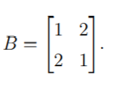  ANSWER  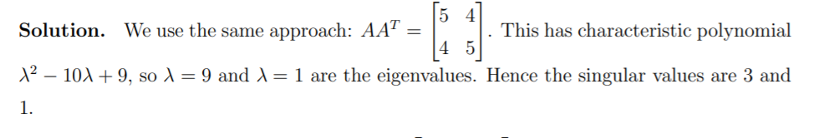 | 3
 | c) | Explain the Steps of PCA  ANSWER:  Step 1: Standardize the dataset.  Step 2: Calculate the covariance matrix for the features in the dataset.  Step 3: Calculate the eigenvalues and eigenvectors for the covariance matrix.  Step 4: Sort eigenvalues and their corresponding eigenvectors.  Step 5: Pick k eigenvalues and form a matrix of eigenvectors.  Step 6: Transform the original matrix. | 2
3. | a) | (i) List the 5 main features of genetic algorithms (1)  (ii)What two requirements should a problem satisfy in order to be suitable for solving it by a GA? (2)  (iii)What kind of a population is a genetic algorithm (GA) for optimisation most likely to succeed in? What should ideally be the crossover and mutation probability? (2)  (iv) For a single point crossover with cross over point in the middle what will be the child chromosomes for the following two parent chromosomes 110111 and 100011 (2)  ANSWER  (i) Encoding, Fitness Function, Selection, Cross Over, Mutation  (ii)Answer: GA can only be applied to problems that satisfy the following requirements:  • The fitness function can be well–defined.  • Solutions should be decomposable into steps (building blocks) which  could be then encoded as chromosomes.  (iii) a large diverse population of fit individuals. High crossover probability and low mutation probability  (iv) 110011 100111 | 7
3. | b) | A budget airline company operates 3 plains and employs 5 cabin crews. Only one crew can operate on any plane on a single day, and each crew cannot work for more than two days in a row. The company uses all planes every day. A Genetic Algorithm is used to work out the best combination of crews on any particular day.  a) Suggest what chromosome could represent an individual in this algo-  rithm?  b) Suggest a fitness function for this problem.  ANSWER  - On each day, a solution is a combination of 3 cabin crews assigned to 5 airplanes. Thus, a chromosome of 3 genes could be used in this algorithm with each gene representing a crew on a certain plain. (1.5)  - You may come up with different versions, but it is important for fitness to take into account the condition that cabin crews cannot work more than 2 days in a row. For example, the fitness function can take into account how many days each crew has left before a day off (e.g. 1 or 0). The fitness could be calculated as the sum of these numbers for all drivers in the chromosome. (1.5) | 3
4. | a) | Suppose a genetic algorithm uses chromosomes of the form  x = abcdefgh with a fixed length of eight genes. Each gene can be any digit between 0 and 9. Let the fitness of individual x be calculated as:  f(x) = (a + b) − (c + d) + (e + f) − (g + h) , and let the initial population consist of four individuals with the following chromosomes:  x1 = 6 5 4 1 3 5 3 2  x2 = 8 7 1 2 6 6 0 1  x3 = 2 3 9 2 1 2 8 5  x4 = 4 1 8 5 2 0 9 4  a) Evaluate the fitness of each individual, showing all your workings, and arrange them in order with the fittest first and the least fit last. (2)  b)Perform the following crossover operations:  (i) Cross the fittest two individuals using one–point crossover at the  middle point. (1)  (ii) Cross the first and third fittest individuals (ranked 1st and 3rd)  using a uniform crossover. (1)  (iii) Evaluate the fitness of the new population consisting of the 4 offsprings resulting from the crossover previous questions. Has the overall fitness improved? (3)  ANSWER  Answer:  f(x1) = (6 + 5) − (4 + 1) + (3 + 5) − (3 + 2) = 9  f(x2) = (8 + 7) − (1 + 2) + (6 + 6) − (0 + 1) = 23  f(x3) = (2 + 3) − (9 + 2) + (1 + 2) − (8 + 5) = −16  f(x4) = (4 + 1) − (8 + 5) + (2 + 0) − (9 + 4) = −19  The order is x2, x1, x3 and x4.  Answer: One–point crossover on x2 and x1:  x2 = 8 7 1 2 6 6 0 1  x1 = 6 5 4 1 3 5 3 2 ⇒ O1 = 8 7 1 2 3 5 3 2, O2 = 6 5 4 1 6 6 0 1  Answer: In the simplest case uniform crossover means just a  random exchange of genes between two parents. For example, we  may swap genes at positions a, d and f of parents x2 and x3:  x2 = 8 7 1 2 6 6 0 1  x3 = 2 3 9 2 1 2 8 5 ⇒ O3 = 2 7 1 2 6 2 0 1, O4 = 8 3 9 2 1 6 8 5  Answer: The new population is:  O1 = 8 7 1 2 3 5 3 2  O2 = 6 5 4 1 6 6 0 1  O3 = 2 7 1 2 6 2 0 1  O4 = 8 3 9 2 1 6 8 5  Now apply the fitness function f(x) = (a+b)−(c+d)+(e+f)−(g+h):  f(O1) = (8 + 7) − (1 + 2) + (3 + 5) − (3 + 2) = 15  f(O2) = (6 + 5) − (4 + 1) + (6 + 6) − (0 + 1) = 17  f(O3) = (2 + 7) − (1 + 2) + (6 + 2) − (0 + 1) = 13  f(O4) = (8 + 3) − (9 + 2) + (1 + 6) − (8 + 5) = −6 | 7
4. | b) | i) If the population size is N and the number of iterations is T, how many times the objective function is to be evaluated (including the initial objective function evaluations) in PSO?  ii) How many user defined parameters are required in PSO apart from the population size and number of iterations?  ANSWER  (i) N+NT  (ii) 3 | 2
4. | c) | The VC dimension of hypothesis space H1 is larger than the VC dimension of hypothesis space H2. Which of the following can be inferred from this?  A) The number of examples required for learning a hypothesis in H1 is larger than the  number of examples required for H2.  B) The number of examples required for learning a hypothesis in H1 is smaller than the  number of examples required for H2.  C) No relation to number of samples required for PAC learning.  ANSWER  A) The number of examples required for learning a hypothesis in H1 is larger than the  number of examples required for H2. | 1

